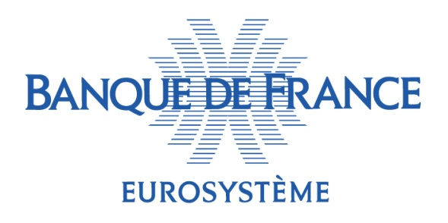

**EMBARGOED UNTIL 14 OCTOBER 2025**

**CHECK AGAINST DELIVERY**

**Bloomberg Global Regulatory Forum – 14 October 2025**

**“Preserving the transatlantic dialogue despite our recent divergences”**

# Speech by François Villeroy de Galhau

# Governor of the Banque de France

*Press contact: Delphine Cuny (* [*delphine.cuny@banque-france.fr*](mailto:delphine.cuny@banque-france.fr)

Ladies and Gentlemen,

I am honored to speak before you today in New York at the Bloomberg Global Regulatory Forum. I will speak here as a European, and as a friend of America. Let us acknowledge that maintaining this dual identity has come under significant strain over the past year: you are well aware that the institutional, geopolitical and economic shifts introduced by the new US administration are prompting serious questions among the friends of America worldwide – and not only in Europe. I am aware that what is perceived as Europe’s persistent economic lag raises doubts here in the United States. So, I will begin by giving some insights about Europe’s economic awakening which is – although too slow – underway (I). Then, I will explore how a stronger Europe could preserve a fruitful dialogue with the United States based on some focused and shared long-term interests (II) – and here I will come to the subject of financial regulation as addressed by this morning’s session.

**I. Europe’s economic awakening is gradually taking shape**

*1. Europe’s underestimated strengths*

On this side of the Atlantic, Europe is sometimes described as a declining economic partner, slow to react and short on momentum. True, Europe is lagging behind in terms of economic dynamism: over the last 25 years, GDP per capita has increased by a cumulative 31% in the euro area – not that bad, but much lower than 47% in the United States. The main cause for this is “Schumpeterian” – an innovation gap – as highlighted by the French economist Philippe Aghion, co-recipient yesterday of the 2025 Nobel Prize in Economics; as you can see, French and European people can be Schumpeterian! Beyond that, Europe has smaller financial firepower, even though its single market is fairly similar in size to the United States. However, Europe does not lack savings: the euro area household saving ratio is more than 15% of gross disposable income, which is 4 points higher than in the United States (11%). The challenge concerns the allocation of these savings: the euro area lacks equity capital, which is vital to enable firms to innovate due to the higher associated risk. Non-financial corporation (NFC) equity financing amounts to just 85% of GDP in the euro area, compared with 220% of GDP in the United States.

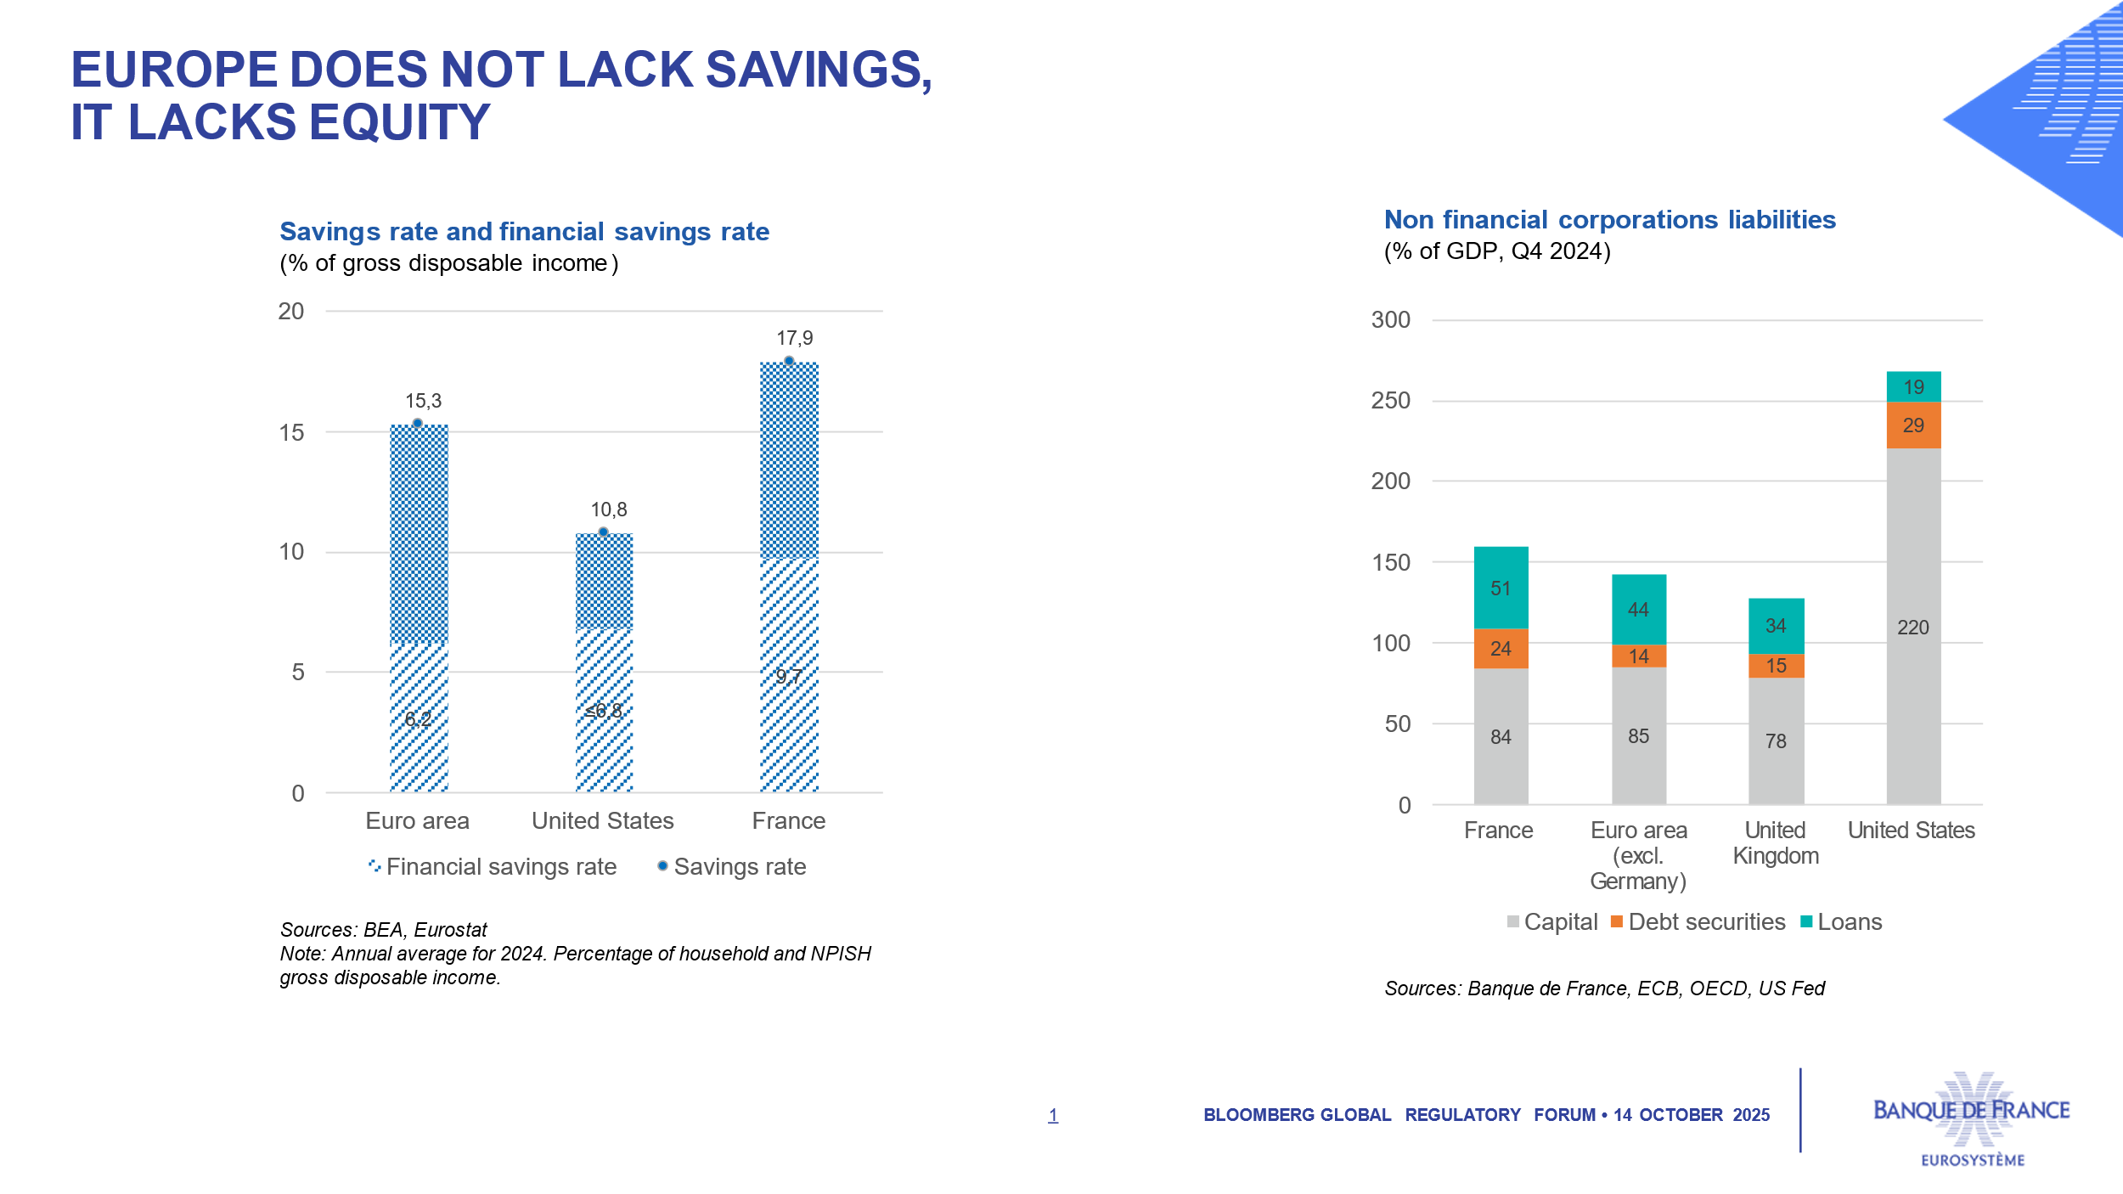

Europe does not lack investment either: as a share of GDP, total investment in the euro area is almost the same as in the United States. But productive investment and, above all, innovative investment are significantly lower in the euro area.

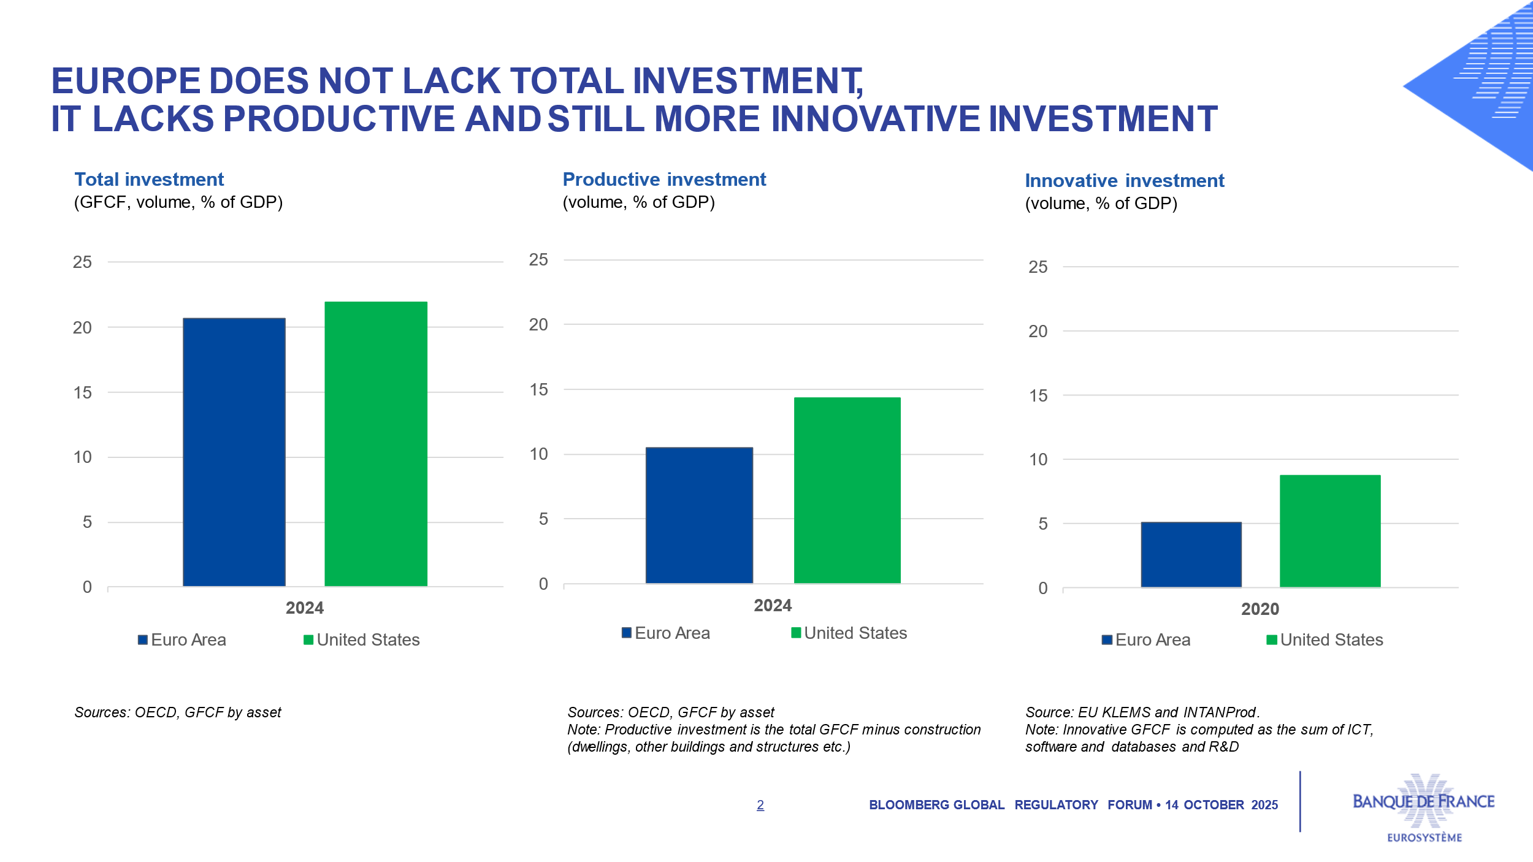

We have the domestic resources – talents, private money, and the largest single market [on par with the United States]. But we need to mobilize them…and the recent US shifts are – if anything positive – a powerful wake-up call.

*2. Europe’s awakening is taking shape*

Let me first remind you of a major European achievement. Over the past 26 years, Europe has built its **monetary** sovereignty through the euro – which has become a huge popular success. The public support for our currency among European citizens is at a historic high, reaching 83%[1]. Our monetary policy path is also clearer: for the first time in years, we have returned to the favorable “2-2” zone[2]. Inflation in the euro area is close to our 2% target and our key interest rate has stood at 2% since June 2025 – significantly lower than in the United States or United Kingdom.

We must complement this by securing Europe’s **economic and financial sovereignty**. We Europeans have a clear roadmap – outlined in the Draghi[3] and Letta[4] reports. Since the beginning of 2025, the Commission has launched a series of initiatives around three imperatives, which I call the three “i’s”.

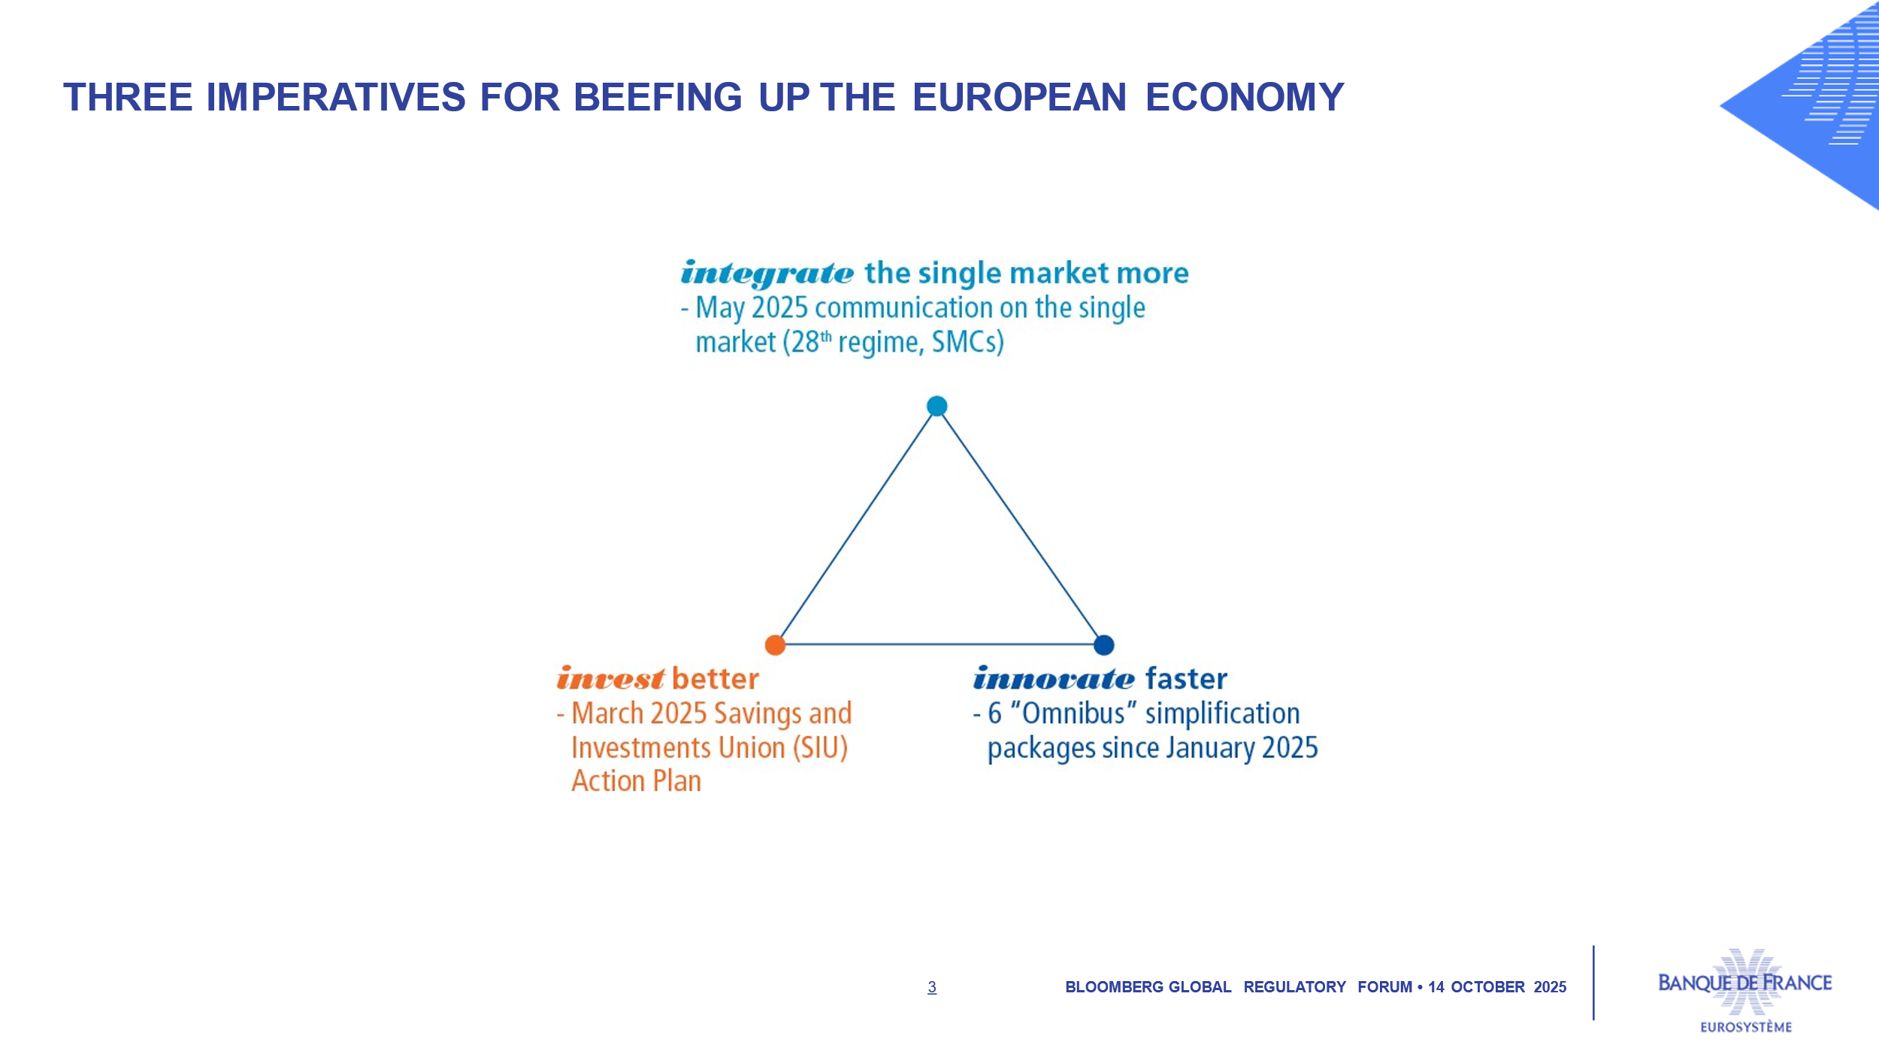

First, we must *integrate* the single market *more*, including the creation of an optional 28th regime, that could reduce the administrative burden for businesses cross-border, and particularly the “cost of failure”[5]. Second, we need to *invest* *better*. I welcome the March 2025 Savings and Investments Union (SIU) Action Plan[6] to channel more of our abundant private savings into European equity financing and venture capital. Third, we need to *innovate* faster, and the Commission has therefore presented several “Omnibus” simplification packages.

True, we still need a comprehensive package and a *mobilizing deadline*[7], as Jacques Delors did in the past with 1 January 1993 for the single market, and 1 January 1999 for the single currency. True, progress takes time, partly due to the necessary dialogue with the European Parliament. But this belongs to democracy, which we strongly believe in, and Europe has often managed to deliver the right policy framework faster on several key issues such as crypto-asset regulation with the MiCA regulation[8], ahead of GENIUS.

**II. Despite their recent divergence on trade, Europe and the United States should still seek pragmatic areas of convergence.**

*1. Our recent transatlantic divergence*

When we disagree across the Atlantic, we should express it clearly: this is a prerequisite for fair dialogue. We cannot ignore the serious disagreements between European and US political authorities on geopolitics and multilateralism. Let me focus here on the economic divergences, and particularly on trade. The protectionist measures adopted by the United States – unprecedented since the 1930s – alongside persistently high unpredictability, represent a negative shock for the global economy, including the American economy itself. In the short term, tariffs do offer a sizeable source of fiscal revenues. But they will not solve the problem of US “twin deficits”. The tariff burden is already primarily borne by US importing firms and in a lesser extent US consumers, and this will eventually weaken economic activity and increase inflation, which is expected to accelerate by the end of the year. What is bad news for the United States is also bad news for Europe. The impact on euro area inflation, however, should remain negligible as the European Union did not retaliate. Let me state the obvious: international trade is not a zero-sum game[9], where one party’s gain necessarily comes at the expense of another. On the contrary, it remains the most effective way to grow together by exchanging goods and services, ideas, talent and innovation[10].

*2. This should not prevent us from seeking pragmatic areas of convergence*

But our transatlantic dialogue cannot be limited to our divergences. We must seek pragmatic areas of convergence through the G7 and the G20, respectively chaired next year by France and the United States, through the IMF where I will be tomorrow, and through the Financial Stability Board (FSB). Let me highlight pragmatically at least three global issues, where our mutual interests could be aligned.

*Financial stability*

I shall begin with financial stability – a global public good, given the cross-border nature of the financial system. I strongly wish we can all stick to the agreed international framework of Basel III for banks and more broadly to the Financial Stability Board (FSB) recommendations. Let us focus on two of the many challenges ahead.

First, the **fight against financial crime**. Europe and the United States should continue to lead by example by strengthening their AML/CFT frameworks and actively encouraging other countries to support the recent G7 “Financial Crime Call to Action”[11]. We should also be vigilant there about the misuse and abuse of cryptos.

Another shared challenge is **non-bank financial intermediation (NBFI**[12]**)** which remains too opaque, highly interconnected, and, in some cases, excessively leveraged[13].

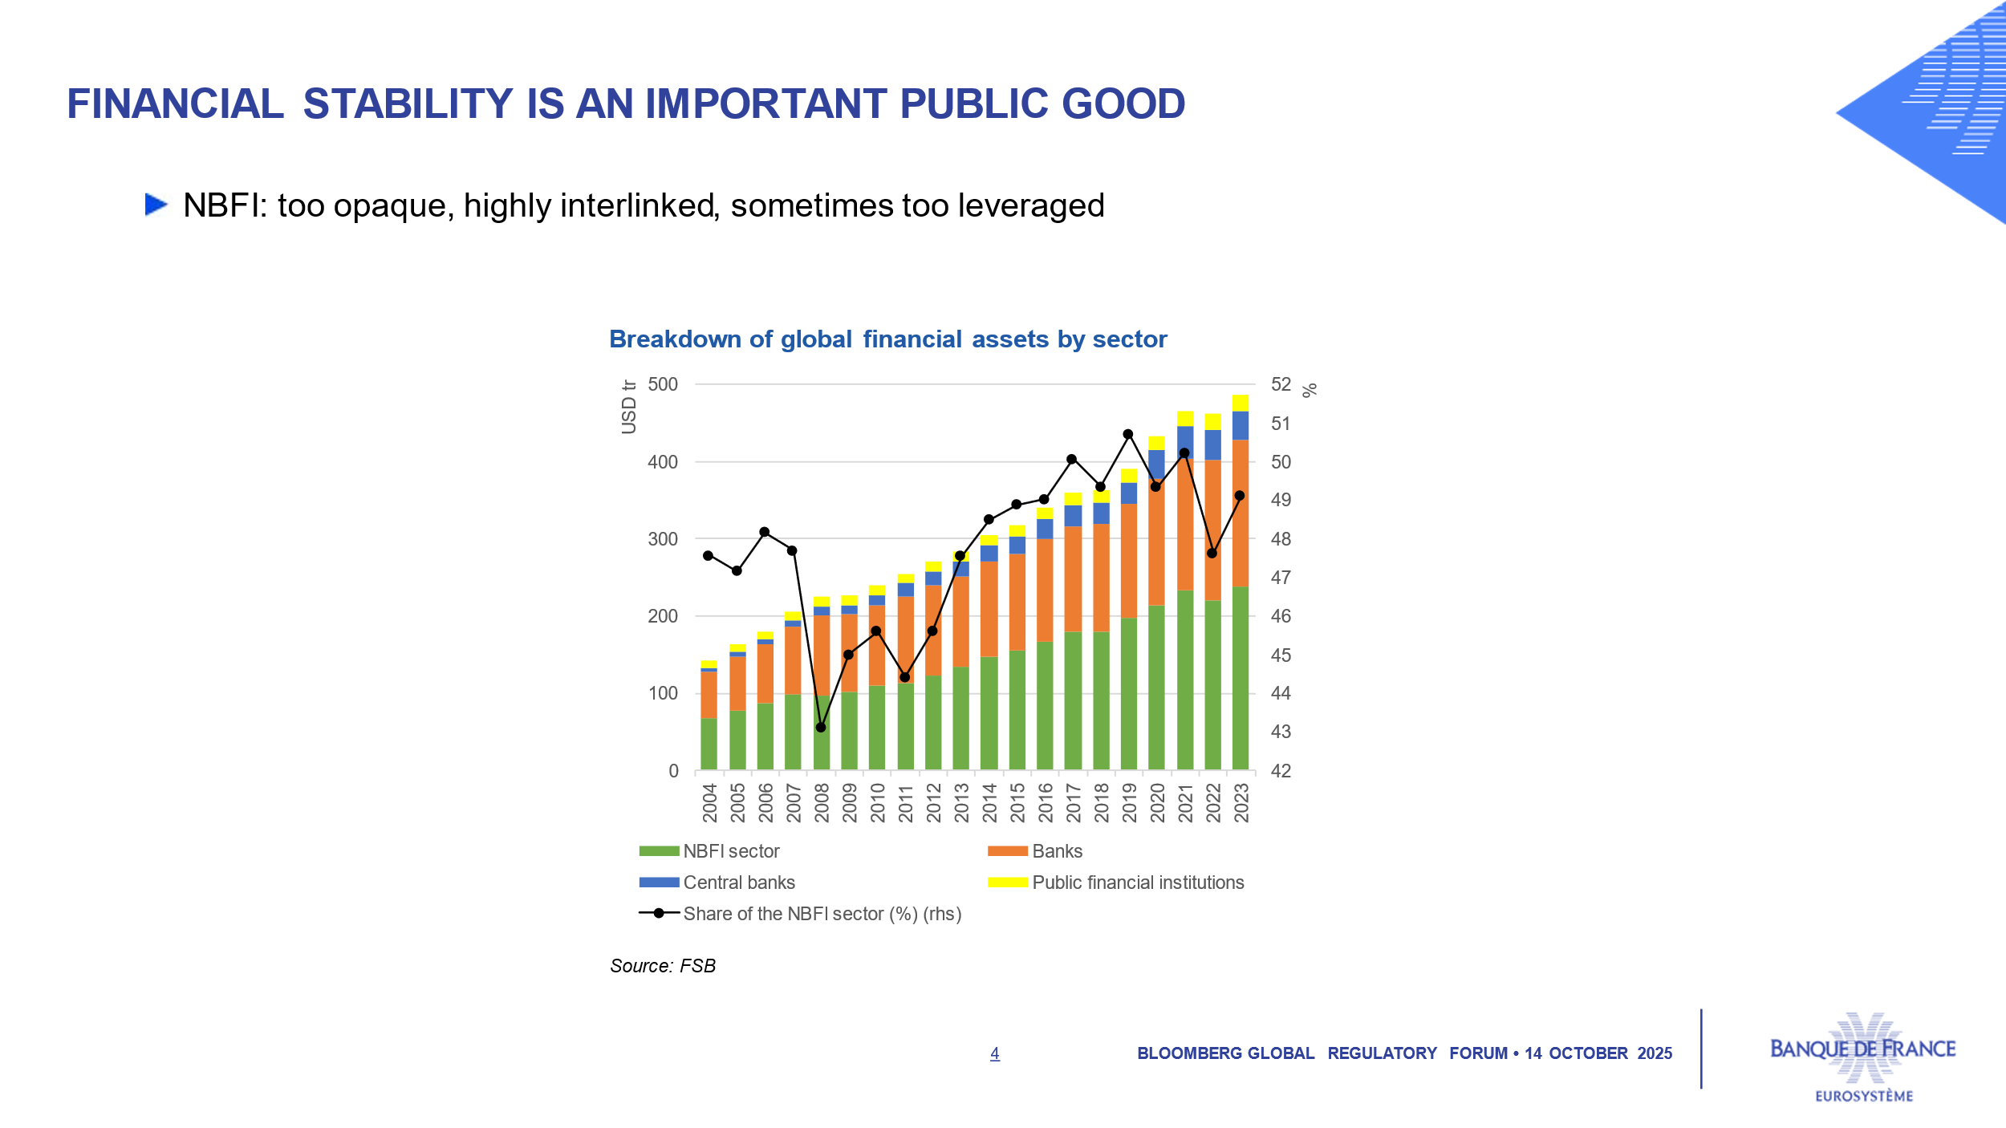

Hedge funds, whose use of leverage is rising both in Europe and the United States, now account for more than 50% of transactions in the secondary European government debt market. These funds operate mostly across borders, making oversight difficult and requiring strong international cooperation to gauge their risks. The rapid growth in private credit – which is transforming the corporate loans market in the United States and expanding in Europe[14] –, is another concern. Although the market is still modest relative to the banking sector, its complex and opaque interconnections with the broader financial system require close coordination to monitor emerging risks.

And if we make progress together in these fields, we could come back to the issue of climate-related risks, or “extreme weather events”. To say the least, climate change is not taking a gap year, while we know this is at present another transatlantic disagreement.

*Technological innovation and disruptions in finance*

Technological disruptions in financeare a second issue. One major innovation is the tokenization of financial assets, which carries a dual promise: improving efficiency in asset transfers, and bridging the gap between savings channels and the financing needs of the real economy. But the rise of private stablecoins, which could reach a market capitalization of between USD 500 billion and 2 trillion by 2028[15], presents two significant challenges: traditional financial actors could be displaced by new technology players, whether in terms of settlement assets or infrastructures; and it could undermine the current balance between central bank money and commercial bank money, posing a potential threat to monetary sovereignty – still more for non-dollar currencies, but also in the United States in the long run. Our Eurosystem’s response to these innovations is based on three components[16]: central bank digital currency, the possibility of a tokenized commercial bank money and regulation. I welcome the fact that US authorities have also begun addressing this issue through the recent GENIUS Act. While our approaches may sometimes differ, continued regulatory cooperation and support for interoperable settlement assets are essential to fully harness the potential of the tokenization revolution.

*Public debt and aging*

The third global issue is that of public debt and aging. A Frenchman is certainly not in a position to give lessons on this matter at the moment — even though the Banque de France consistently and strongly advocates for public deficit reduction, including a significant step in 2026. But I can point out that unfortunately this is a common challenge for most advanced economies. Public debt exceeds 120% of GDP in the United States, and stands at around 90% in the euro area[17] – but is above 100% in many countries.

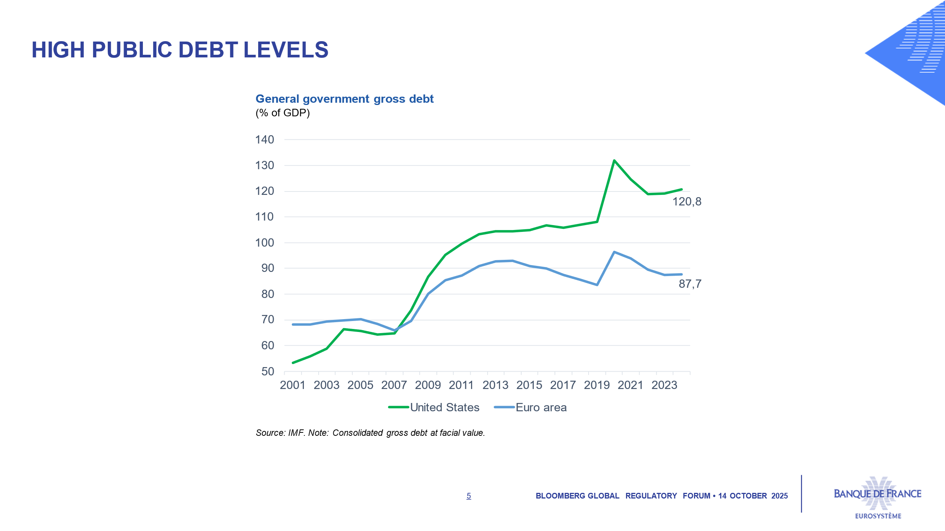

Obviously this is a long-term and cross-generational issue: fiscal policy must first stabilize and then diminish the debt burden. In this context, there is a shared interest in tackling international tax evasion and avoidance, and in benchmarking the most efficient solutions in terms of quality and cost across various sectors, from education to healthcare. Furthermore, public deficits are partly responsible for global imbalances, in parallel with insufficient investment in some jurisdictions and specific practices in some countries like China. Rather than opposing these two explanations, let us acknowledge that both of them are valid, and make progress in the transatlantic dialogue till next year – with the G20 US Presidency, and the G7 French Presidency. Only with greater fiscal efficiency will we be able to finance investments in the structural needs of our economies such as demographic aging, defense spending, and – yes – climate transition.

*

Let me conclude with the words of President George Washington: “True friendship is a plant of slow growth, and must undergo and withstand the shocks of adversity before it is entitled to the appellation”[18]. While Europe and the United States may today face real divergences, they still share deep and long-term interests that call for a demanding but pragmatic dialogue. In parallel, Europe now has the means to strengthen its economic and financial sovereignty, and to become an even more vigorous partner to the United States. Thank you for your attention.

1. European Commission (2025), Eurobarometer – Spring 2025.
2. Villeroy de Galhau (F.) (2025), “[*A mobilising deadline for seizing Europe’s moment*](https://www.banque-france.fr/en/governors-interventions/mobilising-deadline-seizing-europes-moment)”, speech, 14 May.
3. Draghi (M.) (2024), [*The future of European competitiveness*](Draghi%20(M.)%20(2024),%20The%20future%20of%20European%20competitiveness,%20September.), September.
4. Letta (E.) (2024), [*Much more than a market*](https://www.consilium.europa.eu/media/ny3j24sm/much-more-than-a-market-report-by-enrico-letta.pdf), April.
5. Coste, (O.), Coatanlem (Y.) (2024), “The Cost of Failure and the Quest for Competitiveness: Disruptive Innovation as a Catalyst”. *IEP Policy Brief* No. 24, IEP Bocconi
6. European Commission (2025), “[SIU strategy to enhance financial opportunities for EU citizens and businesses](https://finance.ec.europa.eu/publications/savings-and-investments-union-strategy-enhance-financial-opportunities-eu-citizens-and-businesses_en)”, 19 March
7. Villeroy de Galhau (F.) (2025), “[*A mobilising deadline for seizing “Europe’s moment”*](https://www.banque-france.fr/en/governors-interventions/mobilising-deadline-seizing-europes-moment)*”*, speech, 14 May
8. Regulation (EU) 2023/1114 on markets in crypto-assets
9. Villeroy de Galhau (F.) (2025), “[*Preserving our transatlantic values, beyond present unpredictability*](https://www.banque-france.fr/en/governors-interventions/preserving-our-transatlantic-values-beyond-present-unpredictability)”, speech, New-York City, 22 April.
10. Villeroy de Galhau (F.) (2025), “[*Markets and minds : upholding the transatlantic partnership*](https://www.banque-france.fr/en/governors-interventions/markets-and-minds-upholding-transatlantic-partnership)”, speech, Atlantic Council, Washington, 23 April.
11. G7 (2025), [FMCBG Communiqué](https://g7.canada.ca/en/news-and-media/news/g7-finance-ministers-central-bank-governors-communique), Banff, 22 May
12. NBFI refers to a system for raising funds and providing funding that involves players outside the traditional banking system. Source: Saillard (M.), Schwenninger (A.) and Watel (A.) (2023), “[Non-bank financial intermediation : vulnerabilities and challenges](https://www.banque-france.fr/system/files/2023-11/Non-bank%20financial%20intermediation_%20vulnerabilities%20and%20challenges_billet_blog_en_327%20-%20Copie.pdf)”, Eco Notepad, Banque de France, September.         
13. Villeroy de Galhau (F.)(2025), “[*Where there is danger, a rescuing element grows as well*](https://www.banque-france.fr/en/governors-interventions/where-there-danger-rescuing-element-grows-well)”, speech, 10 June.
14. In 2024, total assets under management in Europe reached EUR 430 billion, vs EUR 150 billion in 2014. Source: Buch (C.) (2025), “[Hidden leverage and blind spots : addressing banks’ exposures to private market funds](https://www.bankingsupervision.europa.eu/press/blog/2025/html/ssm.blog20250603~7af4ffc2d7.en.html)”, The Supervision Blog, 3 June. It should be noted that these estimates are based on market data due to a lack of official data sources on this market.   
15. J.P. Morgan (2025), “[What to know about stablecoins](https://www.jpmorgan.com/insights/global-research/currencies/stablecoins)”, Global Research, 4 September; Bloomberg (2025), “[Stablecoin Sector May Reach $2 Trillion: Standard Chartered](https://www.bloomberg.com/news/articles/2025-04-15/stablecoin-sector-may-reach-2-trillion-standard-chartered-says)”, 15 April
16. Villeroy de Galhau, (F.) (2025), “[*Europe has the means to respond strategically to the currency revolution*](https://www.banque-france.fr/en/governors-interventions/le-grand-continent-europe-has-means)”, Le Grand Continent, 25 September.
17. IMF (2025)
18. Washington (G.) (1783), Letter from George Washington to his nephew, Bushrod Washington, 15 January.