Explainer T2S Simulator



Version: 1.2

Date: 28/03/2022

Contents

1 Introduction to scenarios 3

2 Reference documents 3

3 Processing 4

3.1 Automatic Mode 5

3.1.1 Inbound camt.050 5

3.1.2 Inbound camt.003 5

3.1.3 Inbound camt.019 5

3.2 Manual Mode 6

3.2.1 XML upload 6

3.3 Liquidity monitoring in CLM 7

3.3.1 Procedure: 7

3.3.2 Related screens 7

3.4 Inter-service liquidity transfer simulator 8

3.4.1 RTGS/CLM push Inter-service liquidity transfers 8

3.4.2 CLM pull U2A Inter-service liquidity transfers 8

3.5 General Ledger file processing 9

3.5.1 camt.019 (Stop accepting outbound inter-service liquidity transfers) is sent to the simulator via event “Start of EoD”. 9

4 Indications for filling the template: 11

5 Operational procedure 12

# Introduction to scenarios

The T2S-TIPS Simulator in coaction with RTGS/CLM is able to perform the following business cases:

* CLM U2A Liquidity monitoring
* RTGS/CLM push A2A Inter-service liquidity transfers
* RTGS/CLM push U2A Inter-service liquidity transfers
* CLM pull U2A Inter-service liquidity transfers
* General Ledger file processing with CLM

The T2S-TIPS Simulator accepts camt.003, camt.025, camt.019 and camt.050 messages from CLM. Messages sent from RTGS to the Simulator are routed via CLM.

The T2S-TIPS Simulator sends camt.004, camt.025, camt.053 and camt.050 messages to CLM. Messages sent by the Simulator may be routed to RTGS via CLM.

# Reference documents

|  |  |
| --- | --- |
| ID | Name of document |
| 1 | T2 User Handbook v1.5 – Central Liquidity Management (CLM) V2.2 |
| 2 | T2 User Handbook v1.5 – Real-Time Gross Settlement (RTGS) V2.2 |
| 3 | TIPS and T2S simulator - cash account liquidity reference data template_.xlsx |
| 4 | Message Types:   1. admi_007_Internal_Receipt_Acknowledgement__ISO_ver_admi_007_001_01_Internal_Receipt_Acknowledgement__20210120_0617_enriched.xsd 2. camt_003_Internal_GetAccount_camt_003_GetAccount_camt_003_001_07_20210122_1414_enriched.xsd 3. camt_004_Internal_ReturnAccount_camt_004_ReturnAccount_camt_004_001_08_20210122_1415_enriched.xsd 4. camt_019_Internal_ReturnBusinessDayInformation_camt_019_ReturnBusinessDayInformation_camt_019_001_07_20201110_0951_enriched.xsd 5. camt_025_Internal_Receipt_camt_025_Receipt_camt_025_001_05_20200811_0838_enriched.xsd 6. camt_050_Internal_LiquidityTransfer_camt_050_LiquidityCreditTransfer_camt_050_001_05_20210122_1418_enriched.xsd 7. camt_053_Internal_TARGET_Services_GeneralLedger_camt_053_BankToCustomerStatement_camt_053_001_08_20200729_0836_enriched.xsd 8. head_001_Internal_BAH_head_001_001_01_Internal_BAH_20210115_1555_enriched.xsd 9. Internal_CLM_BusinessFileHeader_head_002_BusinessFileHeader_head_002_001_01_20210127_1359_enriched.xsd 10. Internal_RTGS_BusinessFileHeader_head_002_BusinessFileHeader_head_002_001_01_20210127_1402_enriched.xsd |

# Processing

The T2S-TIPS Simulator processes messages in two different modes, the automatic response mode and the manual mode.

The response mode is determined for each possible message type by a parameter which is configured by the Operator. For the inbound camt.025 no configuration is needed because the only executed processing for this type of inbound message is its storage by the simulator.

The Simulator offers the possibility to configure the response mode for incoming camt.050 messages per T2S cash account. The configuration has to be indicated in column H of the cash account liquidity reference data template. For the configuration, please look at chapter 4.

For the camt.003 the general behaviour of the simulator has to be defined in the simulator by the operator. For the automatic response to a camt.003, it is possible to choose between a positive response and an automatic error response.

For the camt.019 the general behaviour of the simulator has to be defined in the simulator by the operator. For the automatic response to a camt.019, it is possible to choose between a positive (valid) response and an automatic error (invalid) response. If an automatic error response is configured then an additional error configuration is needed (see paragraph 3.1.3).

The Simulator does not process any message validations apart from the check of the namespace and the related schema.



## Automatic Mode

In the automatic response mode, the T2S-TIPS Simulator processes every incoming valid message automatically. This means, that the related outbound message is created and sent to CLM. The outbound message can be either positive/valid or negative/invalid, depending on the configuration for the inbound message type, as explained above.

The simulator does not update any values during the processing of an inbound message (i.e. an incoming camt.050 will not increase/decrease the configured balances of any referenced cash accounts).

### Inbound camt.050

When receiving a camt.050 inbound message the Simulator checks whether an automated or manual response is configured for the related credit (in case of a push LT) or debit (in case of a pull LT) cash account. When no configuration can be found for the relevant cash account (i.e. cash account number was not defined in the cash account liquidity reference data template) an automatic positive response is provided.

In the automatic mode the Simulator will sent a camt.025 outbound message to CLM. The message contains a settlement status (AUTPOS) or a validation status with an error code and description (AUTERR) depending only on the configuration for the referenced cash account. For the configuration, please look at chapter 4.

The provided cash account liquidity reference data is only used to determine the response mode, but no checks for sufficient liquidity are performed against it. Consequently, it is possible to send messages referring to non-existing cash accounts. There is no business validation within the Simulator and the Simulator does not change the configured balances for the referenced cash account.

In case the credit account number in the camt.050 does not relate to any entry in the Simulator’s static data, the Simulator will interpret the message as a pull liquidity transfer order. When a positive response is configured, the Simulator creates a camt.050 as a second outbound message. This message will have exactly the same payload as the received inbound camt.050 and will be sent to CLM.

### Inbound camt.003

When receiving a camt.003 in automatic response mode the Simulator will create and send a camt.004 to CLM. The outbound message either contains an error code with an error description (AUTERR) or reports all queried balances as specified in the cash account liquidity reference data template.

In case no values are provided for a queried cash account, this cash account will still be part of the camt.004 outbound message and all balances will be reported as “0” in the currency “EUR”. All cash accounts will be returned with either the configured value or “0” for non-configured accounts. There is no error message created in this case, only positive response.

For a liquidity query which queries all account balances for a specified currency (i.e. no cash account numbers are given as input parameters, only a currency) the Simulator checks whether at least one cash account in the indicated currency exists.

### Inbound camt.019

In case a camt.019 inbound message is received the Simulator firstly determines which outbound message is expected based on the provided inbound information. If a system status “STRT” or “STOP” is provided in the inbound message the Simulator creates, stores and sends an outbound receipt (camt.025) to CLM – given an automatic response configuration for this scenario.

Otherwise, the simulator checks whether an automatic mode is configured for the expected general ledger message. In the automatic response mode the Simulator reads the balance of the relevant transit account in CLM so it can provide the expected balances in the general ledger to CLM. The balance of the transit account will be spread to all configured cash accounts in the Simulator (i.e. the balances configured in the Simulator’s data will not be used). The general ledger camt.053 message, which is created by the simulator, is stored and send to CLM either as a valid or as an invalid message, depending on the configuration. It’s possible to configure several outbound message scenarios for invalid General Ledge (AUTINV) response:

* INCONS creates an inconsistent GL-FILE, where the sum auf DCA balances do not match with the amount of the transit account.
* INCTRA creates an inconsistent GL-FILE where the transit accounts of T2S/TIPS and CLM are not matching.
* UNPROC creates an unprocessable GL-FILE (no Transit Account included).
* NSWIFT creates a GL-FILE with a NONSWIFT character as part of the Account Id
* FUTDAT creates a GL-FILE with a date in the future
* LAS5BD creates a GL-FILE with a date within the last 5 business days

This configuration will only be relevant in case an invalid GL file (AUTINV) should be created.

## Manual Mode

**Due to pending restrictions with the functioning of the Manual Mode, currently, it is advised to use the Automatic Mode (refer to section 3.1) for processing the messages.**

When the manual mode is configured as processing mode for any message type no outbound message is created as a response to this message type. The Simulator will only store the inbound message and no more processing will take place.

### XML upload

For all outbound messages that are supported by the Simulator, the Central Bank testers have the possibility to provide a XML files containing any of these messages (one message per file) for upload. This function can be used to provide manual answers to any inbound message. The messages have to be prepared completely (including the BAH) and should be provided to the TARGET Service Desk via mail for the upload. In case the files are provided by a credit institution, the files need to be provided to the National Service Desk, which performs a plausibility check and forwards the files to the TARGET Service Desk. Once the upload is performed, the T2S-TIPS Simulator will send the message to CLM.

## Liquidity monitoring in CLM

In the relevant GUI screen, it is possible to display the current liquidity of the TIPS and T2S DCAs. If the simulator is active, a camt.003 is generated when the screen is used and sent to the simulator. Depending on the setting, the simulator responds with a camt.004.

### Procedure:

1. camt.003 is sent to the simulator via U2A
2. T2S-TIPS simulator answers:
   1. configured response mode = manual,

In the case of a manual response mode, no action is performed by the simulator. The respective service now waits for a response. This response can be imported via the upload process described in 3.2.1. Please take into account that the timeout for the CLM GUI is 60 seconds.

* 1. configured response mode = positive automatic

In the case of a positive automatic response mode, the simulator reads all the relevant account balances which were provided via the excel spreadsheet. The simulator creates a camt.004 with all account balances of 3b.

* 1. configured response mode = negative automatic

In the case of a negative automatic response mode, the simulator creates a camt.004 with error code “SIM1” and error description “SIM automatic error response mode”.

### Related screens

Screen access can be reached in the following way:

1. Monitoring >> Available Liquidity by Party

Further information is in UHB at chapter 5.8.6 Available Liquidity by Party – Query Screen

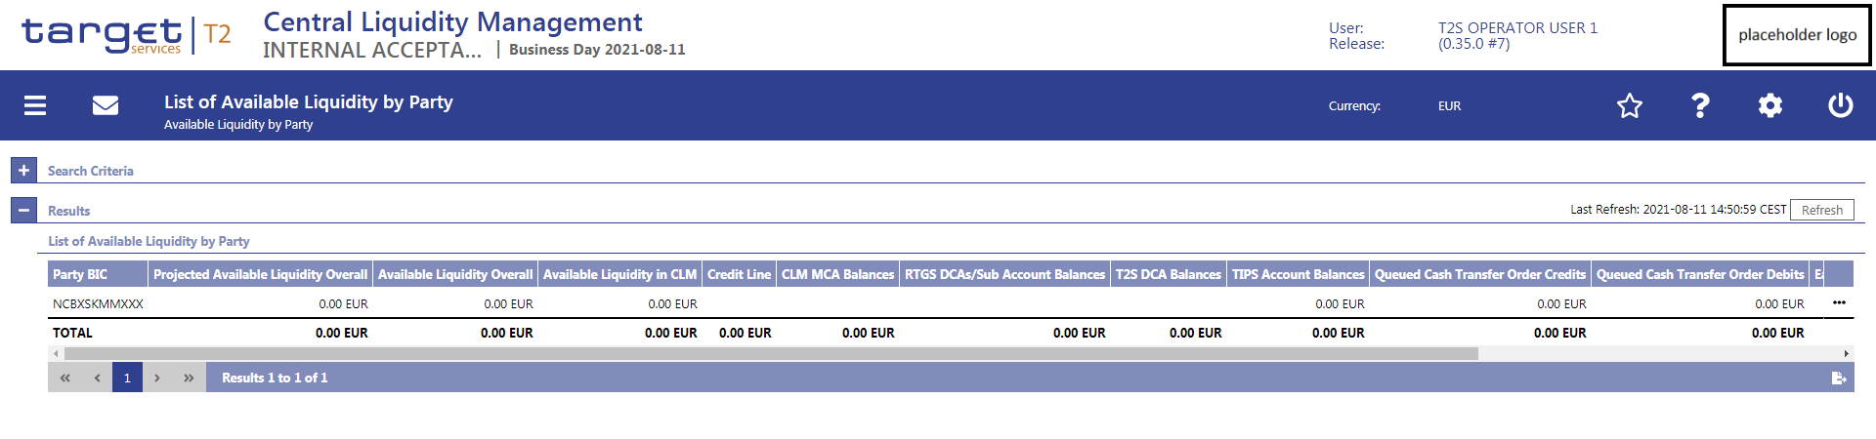

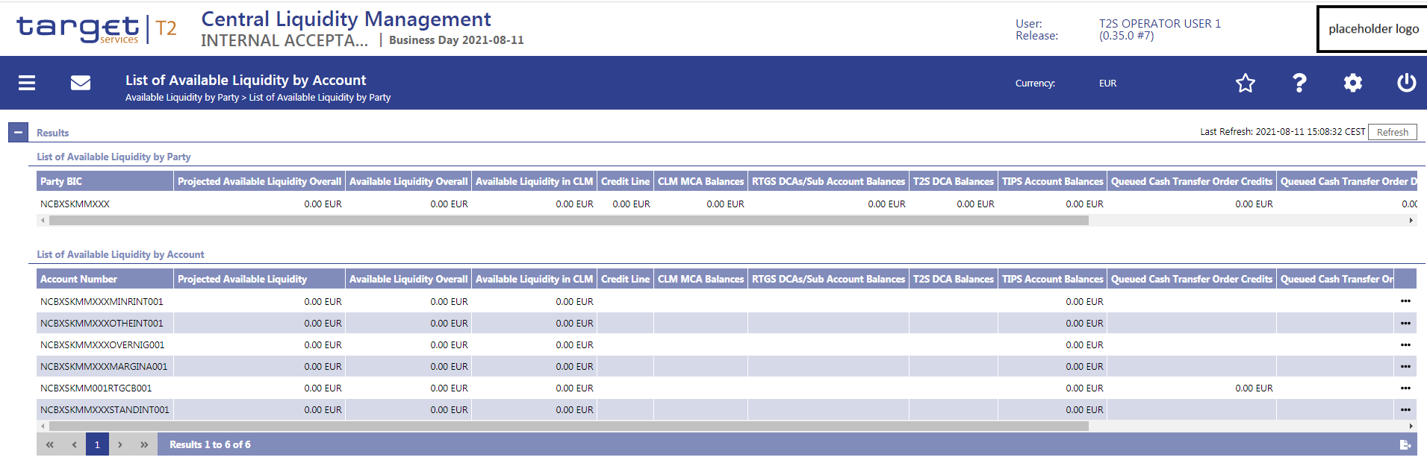

## Inter-service liquidity transfer simulator

The simulator does not update any values during the processing of an inbound message (i.e. an incoming camt.050 will not increase/decrease the configured balances of any referenced cash accounts).

### RTGS/CLM push Inter-service liquidity transfers

Push Liquidity Transfers can be initialised in RTGS and CLM via U2A and A2A.

#### Procedure:

1. camt.050 is sent to the simulator via U2A or A2A
2. Response Mode = manual or automatic
   1. In the case of a manual response mode, no action is performed by the simulator. The respective service now waits for a response. This response can be imported via the upload process described in 3.2.1.
   2. In the case of an automatic response mode, the simulator checks whether a positive or negative response is configured.
      1. In the case of an automatic negative response, the simulator creates a camt.025 with error code “SIM1” and error description “SIM automatic error response mode”.
      2. In the case of an automatic positive response, the simulator creates a camt.025 with status code “SSET” and sends it to CLM. The response values are set according to the CLM standard processing for inter services.

### CLM pull U2A Inter-service liquidity transfers

Pull Liquidity Transfers can be initiated in CLM only via U2A.

Procedure:

1. camt.050 is sent to the simulator via U2A
2. Response Mode = manual or automatic
   1. In the case of a manual response mode, no action is performed by the simulator. The respective service now waits for a response. This response can be imported via the upload process described in 3.2.1.
   2. In the case of an automatic response mode, the simulator checks whether a positive or negative response is configured.
      1. In the case of an automatic negative response, the simulator creates a camt.025 with error code “SIM1” and error description “SIM automatic error response mode”.
      2. In the case of an automatic positive response, the simulator creates
         1. a camt.025 with status code “SSET” and sends it to CLM and
         2. a camt.050 as a full copy of the inbound camt.050 and sends it to CLM
         3. The response values are set according to the CLM standard processing for inter services.

## General Ledger file processing

After all inter-service liquidity transfers are stopped in CLM, a camt.019 (Generate General Ledger) is automatically sent to the target settlement services RTGS, TIPS and T2S. If the simulator is active, the camt.019 is sent to the simulator instead to T2S/TIPS, which either generates an automatic response (camt.025 and camt.053) or waits for a manual response depending on how the response mode is configured (configuration can be done by operator).

Procedure:

### camt.019 (Stop accepting outbound inter-service liquidity transfers) is sent to the simulator via event “Start of EoD”.

1. the simulator stores the camt.019
2. Response Mode = manual or automatic
   1. In the case of a manual response mode, no action is performed by the simulator. The respective service now waits for a response. This response can be imported via the usual test process.
   2. In the case of an automatic response mode, the simulator creates a camt.025 with status code “CMPT”. The camt.025 is send to CLM.
3. camt.019 (Generate General Ledger) is sent to the simulator via event “Start of EoD
4. the simulator stores the camt.019
5. the simulator stores the camt.019
6. Response Mode = manual or automatic
   1. In the case of a manual response mode, no action is performed by the simulator. The respective service now waits for a response. This response can be imported via the usual test process.
   2. In the case of an automatic response mode, the simulator creates a camt.053 with the following properties:
      1. all accounts (no balances)
      2. liquidity of the relevant CLM transit accounts
      3. valid camt.053 = The liquidity of the transit accounts is divided by the Simulator among the configured accounts in the Simulator.
      4. Invalid camt.053 = Adjustments to the message depending on the scenario.
   3. The camt.053 is send to CLM.
   4. CLM provides the final GL to the end users

# Indications for filling the template:

A value for every column excluding AVAIL_COLL_T2S and OUTST_AUTO_COLL_T2S has to be provided.

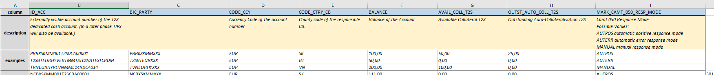

For column BALANCE also negative balances can be provided in order to test the scenario for T2S Central Bank Accounts.

There are three possible response modes for the camt.050:

AUTPOS automatic positive response mode

AUTERR automatic error response mode

MANUAL manual response mode

The response mode for General Ledger and CLM Liquidity Monitoring is not configured on account level but performed in a central way by the operator. Thus, the response mode configured for the respective message type applies to the whole testing community. Please see paragraph 3.1.3.

Attention:   
The TIPS-T2S DCAs which are provided in the templates also have to be configured and set-up in CRDM. This is a pre-condition for the simulator to route the liquidity transfers correctly.

# Operational procedure

For using the simulation tool (T2S) the testers have to fill the column B - H of the excel sheet and submit it to the TARGET Service Desk via mail. In case the files are provided by a credit institution, the files need to be provided to the National Service Desk, which performs a plausibility check and forwards the files to the TARGET Service Desk. Once the upload is performed, the T2S Simulator will send the message to CLM.

The TARGET Service Desk will consolidate the feedback received and insert it into the database in one shot.

We propose to make the initial upload of the loading of DCA balances based on the time period/deadline to be agreed by the MTRSG for the users’ submission of the file and for the TSDs’ processing of the file. As defined by the TOR the need of any additional uploads of these balances must to be requested in the MTRSG which will also confirm the same (e.g. twice or thrice depending on the testing phase).

The upload can be done once an agreement is reached in the MTRSG, which is why we cannot specify a date and time. What is meant is that the community will agree on a deadline where the 4CB needs to receive and upload all the fictitious balances from the community. Once the upload has been done of course only the NCBs which submitted the balance will be able to test the simulator.

Changes in the response mode for camt.003 and camt.019 (automatic positive/negative, manual) are subject to coordination in the MTRSG because they affect the testing of the whole community.

In order to test scenarios in manual response mode, XML files can be sent (via National Service Desk) to the TARGET Service Desk for upload. The file name used (*.xml) must not be longer than 12 characters.