

SWIFT MyStandards Readiness Portal   
-Readiness Portals for external message testing-

|  |  |
| --- | --- |
| Version | 1.00 |
|  |  |

Table of Content

1. Introduction 4

1.1 Purpose of this document 4

1.2 Availability 4

2. Use of the MyStandards Readiness Portal in the CSLD project 4

2.1 T2 Technical Prerequisites 4

2.2 Portal Management/Support 5

2.3 Preconditions for using Readiness Portals 5

2.4 SWIFT MyStandards Readiness Portal structure 6

2.5 Versioning of messages 6

3. Testing of messages 8

3.1 Testing T2 inbound messages 8

3.2 Testing T2 outbound messages 8

4. References 8

# Introduction

## Purpose of this document

The purpose of this document is to describe the set-up process for the Users of the SWIFT MyStandards Readiness Portal in the testing phase of the T2-T2S Consolidation project (CSLD project).

The document gives an introduction and overview on the usage of the SWIFT MyStandards Readiness Portal for the T2 Customer.

## Availability

The T2 customers testing phase with the Readiness Portal starts on July 2019. With the start the SWIFT MyStandards Readiness Portal is available for T2 customers to test the compliance of their messages against message formats published in the Usage Guidelines in SWIFT MyStandards.

# Use of the MyStandards Readiness Portal in the CSLD project

The MyStandards Readiness Portal provides capabilities for testing the compliance of messages with the specifications provided in the User Detailed Functional Specifications (UDFS) and SWIFT MyStandards. It provides direct links to the documentation in MyStandards and sample messages for each Usage Guideline.

All users can test messages using the SWIFT web application MyStandards Readiness Portal against the messaging formats published on MyStandards while the progress and results of the tests can be fully monitored.

The tests with the MyStandards Readiness Portal do neither require nor verify the future connectivity to CSLD via ESMIG. The backend functionality is not subject of the tests by using the MyStandards Readiness Portal either.

## T2 Technical Prerequisites

The MyStandards Readiness Portal is a web application hosted by SWIFT. Users need Internet access, must be registered with SWIFT MyStandards.

Apart from a web browser no further client software for the Readiness Portal users is necessary.

## Portal Management/Support

Following TSWG's decision to use the Swift MyStandards Readiness Portal "without further T2-Service Desk coordination activities", interested users of T2 customers will be asked to create their own MyStandards account, if one does not already exist, and to request participation in the respective community (ReadinessPortal-CLM-Community and/or ReadinessPortal-RTGS-Community).

## Preconditions for using Readiness Portals

The preconditions for T2 customers to use SWIFT MyStandards Readiness Portals are:

1. Every user who wants to test messages has to be registered with SWIFT MyStandards.
2. Every registered MyStandards user can request membership for the open groups RTGS and/or CLM via the request button.
3. Each group member can then request access to the communities ReadinessPortal-RTGS-Community and/or ReadinessPortal-CLM-Community. The request is automatically answered positively. The Readiness Portals are then activated and visible for testing. For the access request please use the button inside the red rectangle (Figure 1). Every Member of the Community can afterwards access the Readiness Portal for testing (Figure 2).

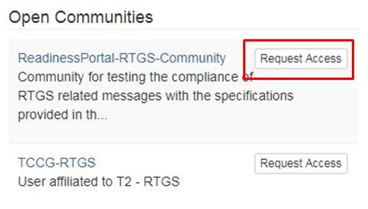

Figure 1: Request Access to ReadinessPortal-RTGS-Community

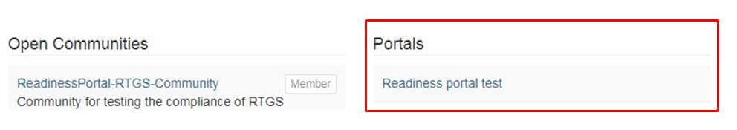

Figure 2: Activated Readiness Portal

## SWIFT MyStandards Readiness Portal structure

The SWIFT MyStandards EMIP group (see level 1) is split into the subgroups RTGS and CLM. In these subgroups (see level 2) the corresponding Usage Guidelines are accessible for the T2 customers.

In each of these subgroups, one portal is created (see level 3).

Within these SWIFT MyStandards Readiness Portals all to be tested messages will be grouped (see level 3) by assigning the Usage Guidelines to the portal.

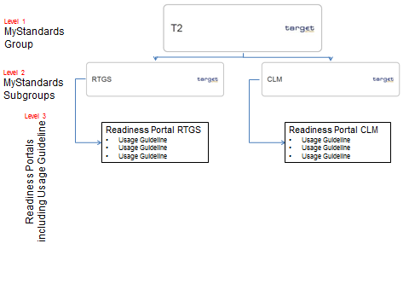

Figure 3: SWIFT MyStandards Readiness Portal structure

## Versioning of messages

In case of new versions of already published Usage Guidelines, respectively messages, the updated versions are added to SWIFT MyStandards by the SWIFT MyStandards Group Owner Team. All uploaded versions of Usage Guidelines are accessible on the SWIFT MyStandards Readiness Portal by the versioning feature.

# Testing of messages

The 4CB offers the T2 customers the possibility to verify their messages’ compliance with the Usage Guidelines published in MyStandards using the SWIFT tool MyStandards Readiness Portal. This service offer is free of charge for T2 customers.

The Readiness Portal serves for testing T2 inbound and T2 outbound messages.

## Testing T2 inbound messages

T2 customers are offered the facility to upload messages to the Readiness Portal in order to verify the compliance of these messages with the messaging formats published on MyStandards.

## Testing T2 outbound messages

To test the processing of T2 outbound messages, for each Usage Guideline non-customer specific sample messages are available in MyStandards. Using these example messages, the T2 customer designs T2 outbound messages based on his test requirements. The compliance of these T2 outbound messages against the messaging formats published on MyStandards can be verified with the use of the Readiness Portal. Once these tests have been successfully completed, the customer can use the syntactically correct messages for functional testing by using them as input message for his systems.

# References

* MyStandards User Guide  
  <https://www2.swift.com/knowledgecentre/publications/mystds_ug/3.0>